Bank Loan Report : Query Document

Bank Loan data

KPI’s

Total Loan Applications

SELECT COUNT(Id) as Toal_loan_applications

FROM Bank_loan_data;



MTD Total Loan Applications (MTD : Month – to – Date)

SELECT COUNT(Id) as MTD_loan_applications

FROM bank_loan_data

WHERE MONTH(issue_date) = 12 AND YEAR(issue_date) = 2021;



PMTD Total Laon Applications (PMTD : Previous Month – to – Date)

SELECT COUNT(Id) as PMTD_loan_applications

FROM bank_loan_data

WHERE MONTH(issue_date) = 11 AND YEAR(issue_date) = 2021;



------------------------------------------------------------------------------------------------

Total Funded Amount

SELECT SUM(loan_amount) as Total_Funded_Amount

FROM bank_loan_data;



MDT Funded Amount

SELECT SUM(loan_amount) as MTD_Funded_Amount

FROM bank_loan_data

WHERE MONTH(issue_date) = 12 AND YEAR(issue_date) = 2021;



PMDT Funded Amount

SELECT SUM(loan_amount) as PMTD_Funded_Amount

FROM bank_loan_data

WHERE MONTH(issue_date) = 11 AND YEAR(issue_date) = 2021;



------------------------------------------------------------------------------------------------

Total Received Amount

SELECT SUM(total_payment) as Total_received_amount

FROM bank_loan_data;



MTD Total Received Amount

SELECT SUM(total_payment) as MTD_Total_received_amount

FROM bank_loan_data

WHERE MONTH(issue_date) = 12 AND YEAR(issue_date) = 2021;



PMTD Total Received Amount

SELECT SUM(total_payment) as PMTD_Total_received_amount

FROM bank_loan_data

WHERE MONTH(issue_date) = 11 AND YEAR(issue_date) = 2021;



------------------------------------------------------------------------------------------------

Average Interest Rate

SELECT ROUND(AVG(int_rate),4) * 100 as Avg_Interest_Rate

FROM bank_loan_data;



MTD Interest Rate

SELECT ROUND(AVG(int_rate),4) * 100 MTD_Interest_Rate

FROM bank_loan_data

WHERE MONTH(issue_date) = 12 AND YEAR(issue_date) = 2021;



------------------------------------------------------------------------------------------------

Average DTI

SELECT ROUND(AVG(dti),4) * 100 as Avg_DTI

FROM bank_loan_data;



MTD Average DTI

SELECT ROUND(AVG(dti),4) * 100 as MTD_Avg_DTI

FROM bank_loan_data

WHERE MONTH(issue_date) = 12 AND YEAR(issue_date) = 2021;



PMTD Average DTI

SELECT ROUND(AVG(dti),4) * 100 as PMTD_Avg_DTI

FROM bank_loan_data

WHERE MONTH(issue_date) = 11 AND YEAR(issue_date) = 2021;



-----------------------------------------------------------------------------------------------

Good Loan Issued

Good Loan Percentage

SELECT (COUNT(CASE WHEN loan_status = 'Fully Paid' OR loan_status = 'Current' THEN id END) * 100)

/ COUNT(id) as Good_laon_Percentage

FROM bank_loan_data;



Good Loan Applications

SELECT COUNT(id) as Total_Good_Loan_applications

FROM bank_loan_data

WHERE loan_status = 'Fully Paid' OR loan_status = 'Current';



Good Loan Funded Amount

SELECT SUM(loan_amount) as Good_Loan_Funded_Amount

FROM bank_loan_data

WHERE loan_status in ('Fully Paid','Current');



Good Loan Amount Received

SELECT SUM(total_payment) as Good_Loan_Amount_Received

FROM bank_loan_data

WHERE loan_status in ('Fully Paid','Current');



------------------------------------------------------------------------------------- ---------

Bad Loans Issued

Bad Loan Percentage

SELECT ROUND((COUNT(CASE WHEN loan_status ='Charged Off' THEN id

END) * 100),4)/ COUNT(id) as Bad_Loan_Percentage

FROM bank_loan_data;



Bad Loan Applications

SELECT COUNT(id) as Bad_Loan_Applications

FROM bank_loan_data

WHERE loan_status = 'Charged Off';



Bad Loan Funded Amount

SELECT SUM(loan_amount) as Bad_Loan_Funded_Amount

FROM bank_loan_data

WHERE loan_status = 'Charged Off';



Bad Loan Received Amount

SELECT SUM(total_payment) as Bad_Loan_Received_Amount

FROM bank_loan_data

WHERE loan_status = 'Charged Off';

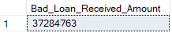

Loan Status

SELECT

loan_status,

COUNT(id) as Total_Loan_Applications,

SUM(total_payment) as Total_Received_Amount,

SUM(loan_amount) as Total_Funded_Amount,

ROUND(AVG(int_rate),4) * 100 as Interest_Rate,

ROUND(AVG(dti),4) * 100 as DTI

FROM

bank_loan_data

GROUP BY

loan_status;

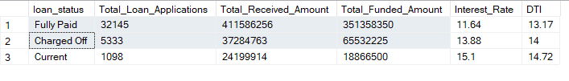

MTD Loan Status

SELECT

loan_status,

COUNT(id) as MTD_Total_Loan_Applications,

SUM(total_payment) as MTD_Total_Received_Amount,

SUM(loan_amount) as MTD_Total_Funded_Amount

FROM

bank_loan_data

WHERE

MONTH(issue_date) = 12

GROUP BY

loan_status;

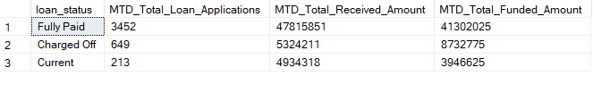

Monthly trend By Issue Date

SELECT

MONTH(issue_date) as Month_Number,

DATENAME(MONTH,issue_date) as Month_Name,

COUNT(id) as Total_Loan_application,

SUM(loan_amount) as Toal_Funded_Amount,

SUM(total_payment) as Total_Received_Amount

FROM

bank_loan_data

GROUP BY MONTH(issue_date),DATENAME(MONTH,issue_date)

ORDER BY MONTH(issue_date);

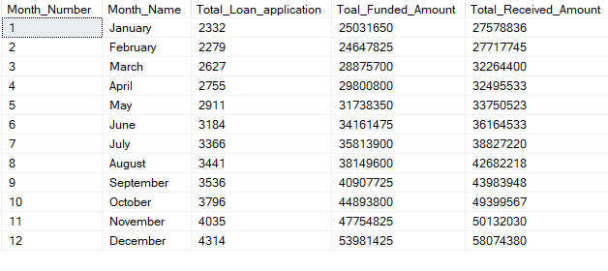

Regional Trend Analysis

SELECT

address_state,

COUNT(id) as Total_Loan_Application,

SUM(loan_amount) as Total_Funded_Amount,

SUM(total_payment) as Total_Received_Amount

FROM

bank_loan_data

GROUP BY address_state

ORDER BY COUNT(id) DESC;

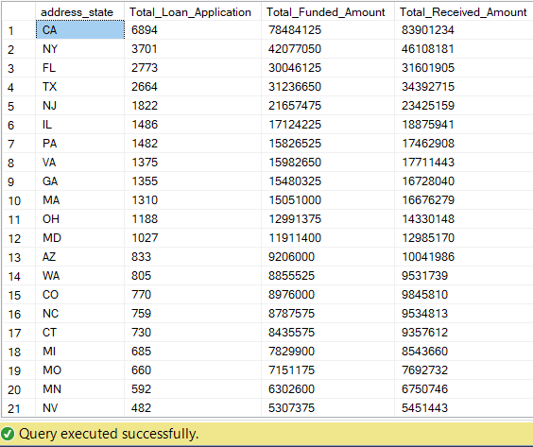

Loan Term Analysis

SELECT

term,

COUNT(id) as Total_Loan_Application,

SUM(loan_amount) as Total_Funded_Amount,

SUM(total_payment) as Total_Received_Amount

FROM

bank_loan_data

GROUP BY term

ORDER BY term;

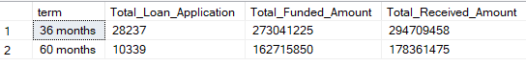

Employee length Analysis

SELECT

emp_length,

COUNT(id) as Toal_loan_applications,

SUM(loan_amount) as Total_Funded_Amount,

SUM(total_payment) as Total_Received_Amount

FROM

bank_loan_data

GROUP BY emp_length

ORDER BY COUNT(id) DESC;

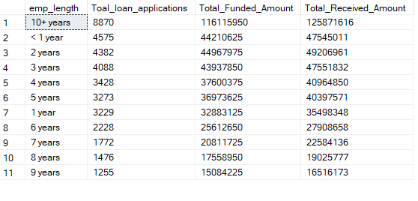

Loan Purpose Breakdown

SELECT

purpose,

COUNT(id) as Toal_loan_applications,

SUM(loan_amount) as Total_Funded_Amount,

SUM(total_payment) as Total_Received_Amount

FROM

bank_loan_data

GROUP BY purpose

ORDER BY COUNT(id) DESC;

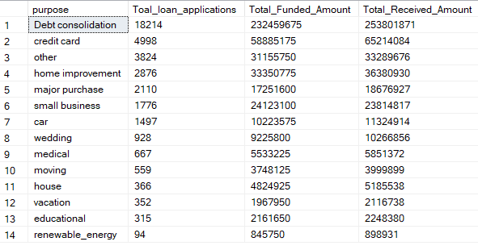

Home Ownership Analysis

SELECT

home_ownership,

COUNT(id) as Toal_loan_applications,

SUM(loan_amount) as Total_Funded_Amount,

SUM(total_payment) as Total_Received_Amount

FROM

bank_loan_data

GROUP BY home_ownership

ORDER BY COUNT(id) DESC;

